Proyecto: “Todos Unidos por un Planeta Mejor”
Escuela de Nivel Inicial Gobernador Miguel Critto
Sala de 4 años
Miss Gilda Beatriz Albarado
Argentina, San Miguel De Tucumán

I SEND PHOTOS OF WEEK OF THE PROJET
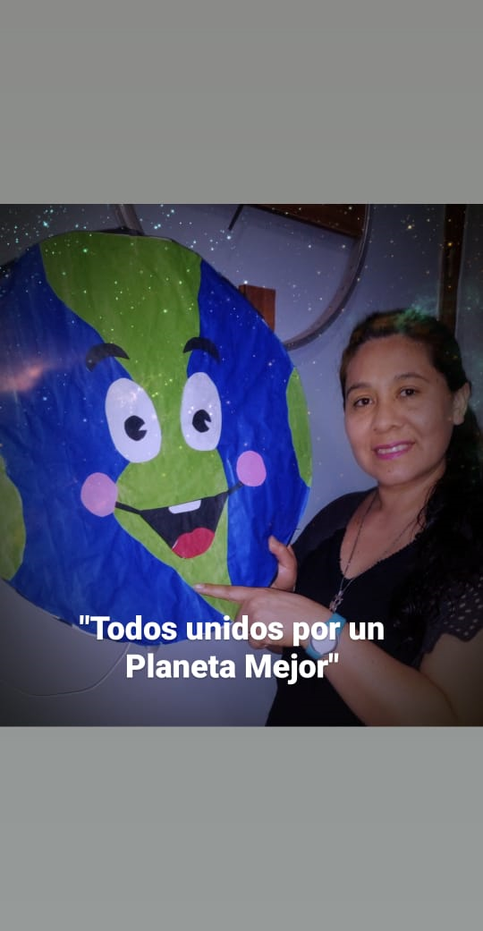
Our planet provide us with all the natural resources. We need to feed ourselves, build our home, providing us the electricity and the transport, get dressed, etc. For this reason, it’s important that working on environment education and following this point of view we must honor our mother earth, the Pachamama.
That is why through this project activities were carried out, firstly providing children with information about the care and preventive measures that our earth needs in order to be free of pollutants such as different human behaviors that har
hat is why through this project activities were carried out, firstly providing children with information about the care and preventive measures that our earth needs in order to be free of pollutants such
as different human behaviors
MA, LITERALLY MEANS MOTHER EARTH
hat is why through this project activities were carried out, firstly providing children with information about the care and preventive measures that our earth needs in order to be free of pollutants such
We learned about the rule of the 3Rs and the idea was to put them into practice, from home, trying to get each family to acquire new habits, one of them was to ask Where do we find garbage? Who throws the garbage in each, where, and when, we reflected on the importance of the garbage can, and even more to classify it into organic waste and what other use they could give it: compost, separate papers, cans and glass.
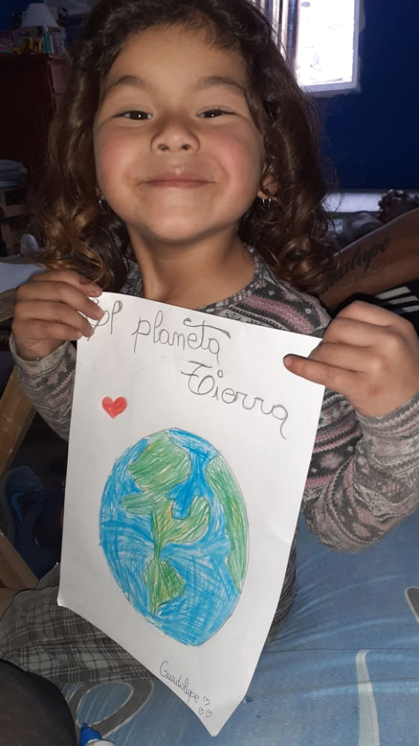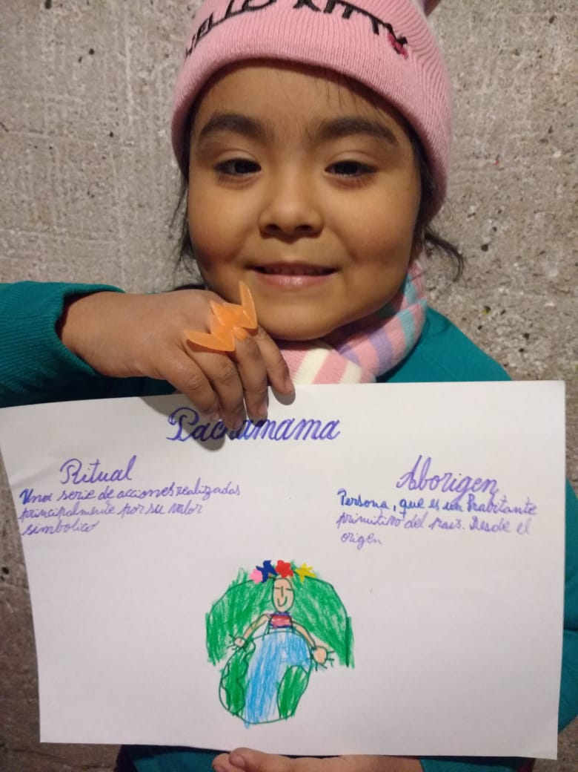
T that harm their well-being.

C LET'S KNOW WHERE WE LIVE: OUR HOUSE, OUR PLANET EARTH
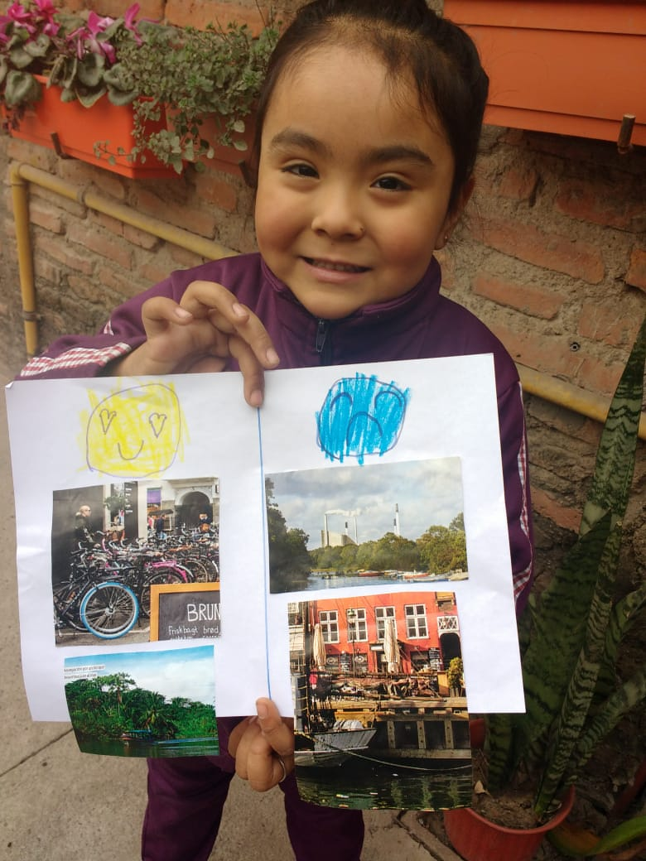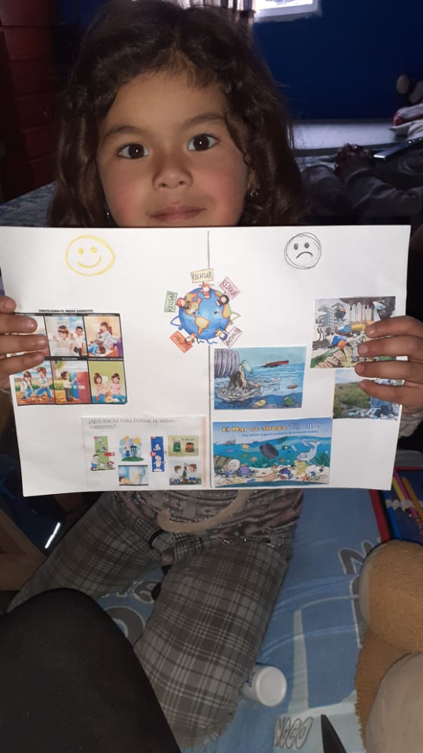
WHAT THINGS DO OUR PLANET GOOD AND WHAT THINGS DO IT WRONG

