Project

School N° 17 Ciudad Autónoma de Buenos Aires. Argentina.

Teacher: Mónica Alejandra Natalia Seta

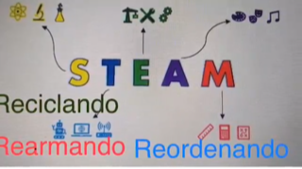 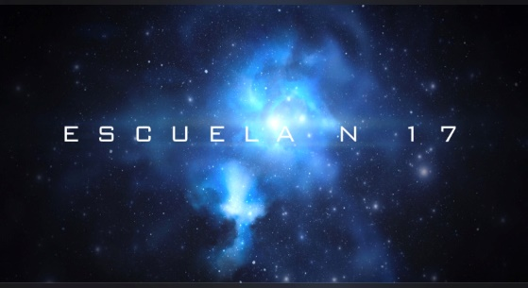

“The integration of the so-called “21st Century Skills and Competencies” into the planning of classes and daily assessments can make a difference in the integration of our students into the life and world of work that they will have to live.

This project, then, proposed a transversal work in all areas.

Achieve that the student leaves the place of mere consumer of technology and becomes the protagonist in the construction of it. Encourage creativity, while working on the construction of a programmable themed robot that understands the basic instructions for coexistence built by first and seventh graders (tutorial program) using Arduino. Inquire about the technological world. Provide varied experiences that can become familiar with the distinctive features of visual language and its multiple modes of organization. Explore with materials and their possibilities. Create, playing. Plan and build. Socialize projects.

