**PROYECTO: “CONSTRUIMOS LA HUERTA EN CASA”**

**PROJECT: “BUILD THE GARDEN AT HOME”**

ESCUELA: De Nivel Inicial Gobernador Miguel Critto

Sala de 5 años (5 year old children)

Miss Analia Fernanda Strelcow

Argentina, Tucumán

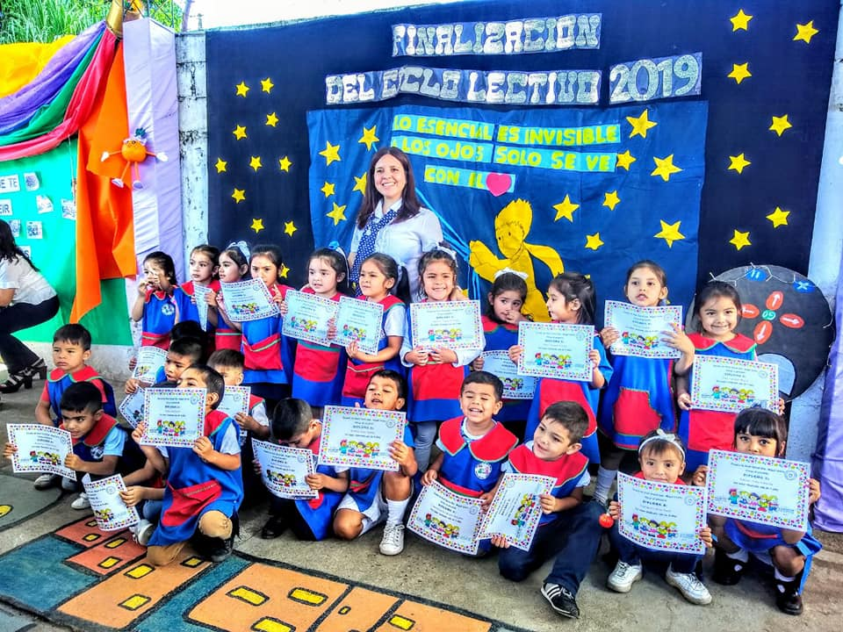

Prepare germinators with bottles, seeds and paper

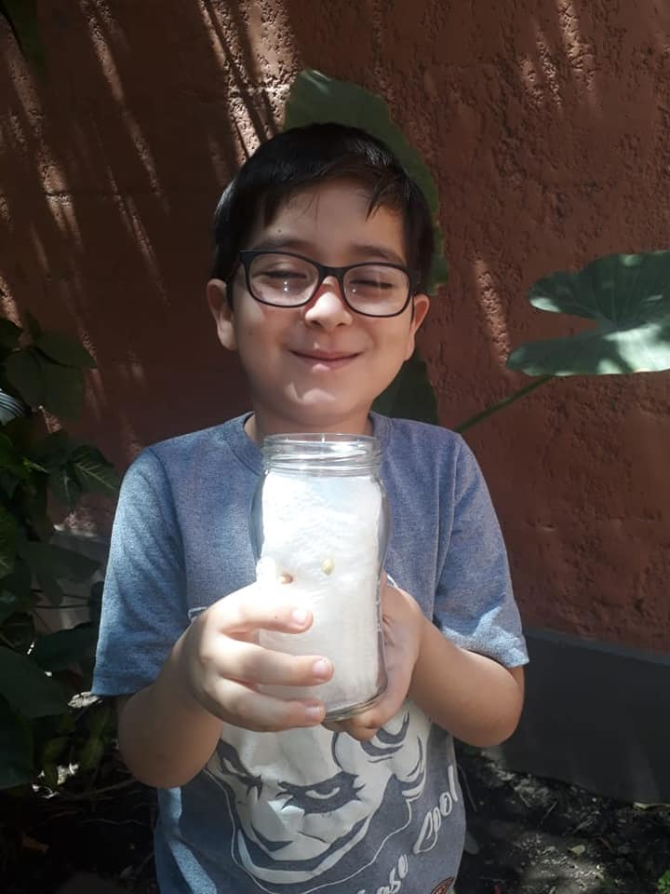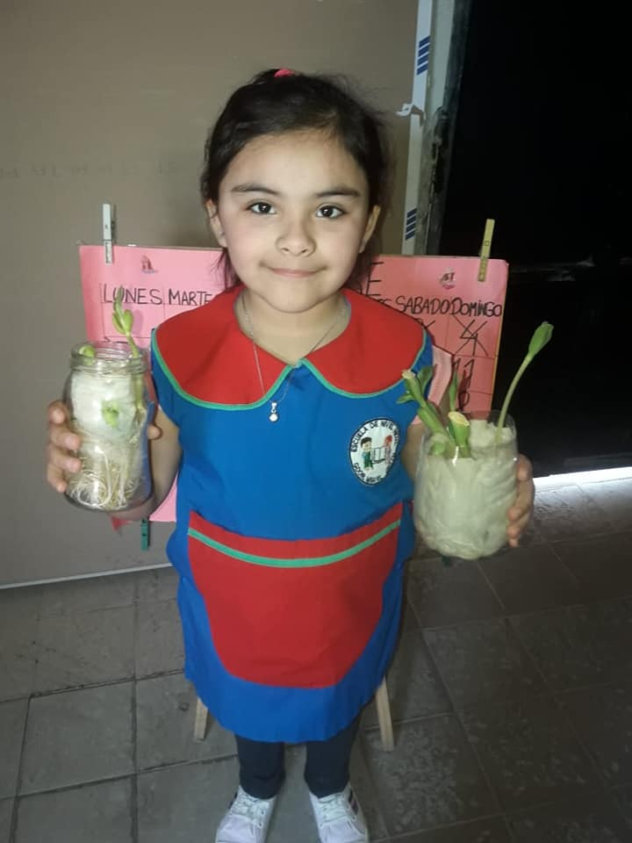

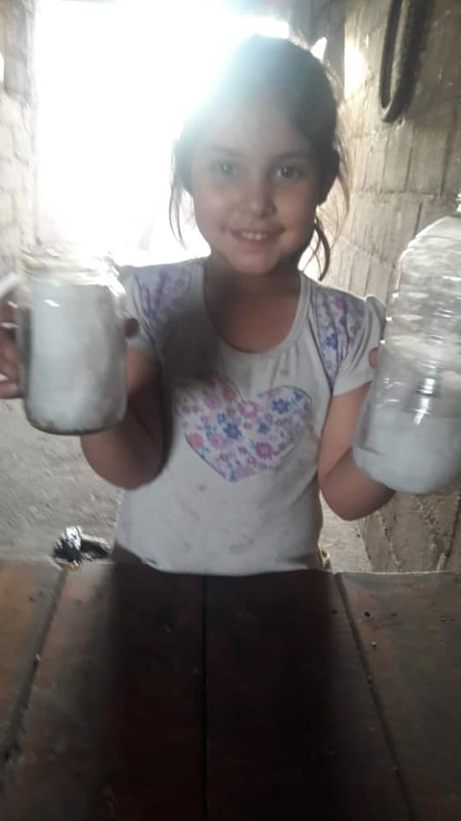 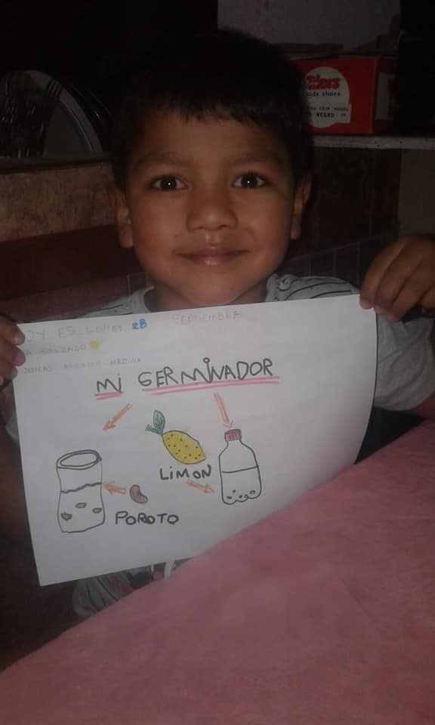

Prepare the soil with organic matter

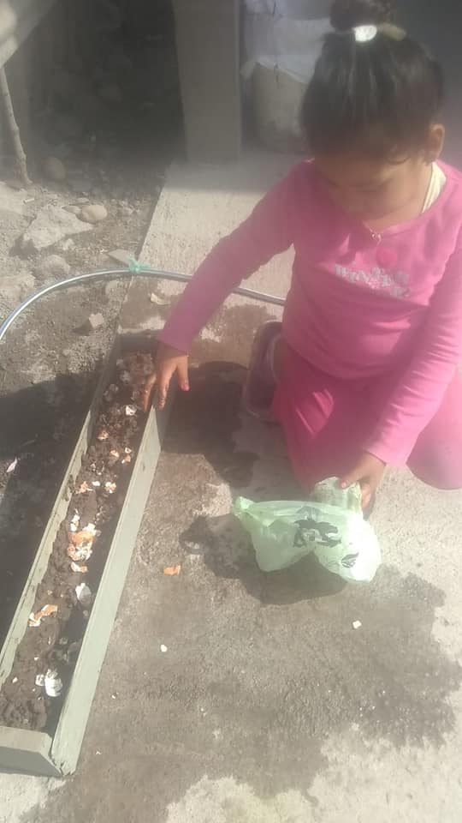 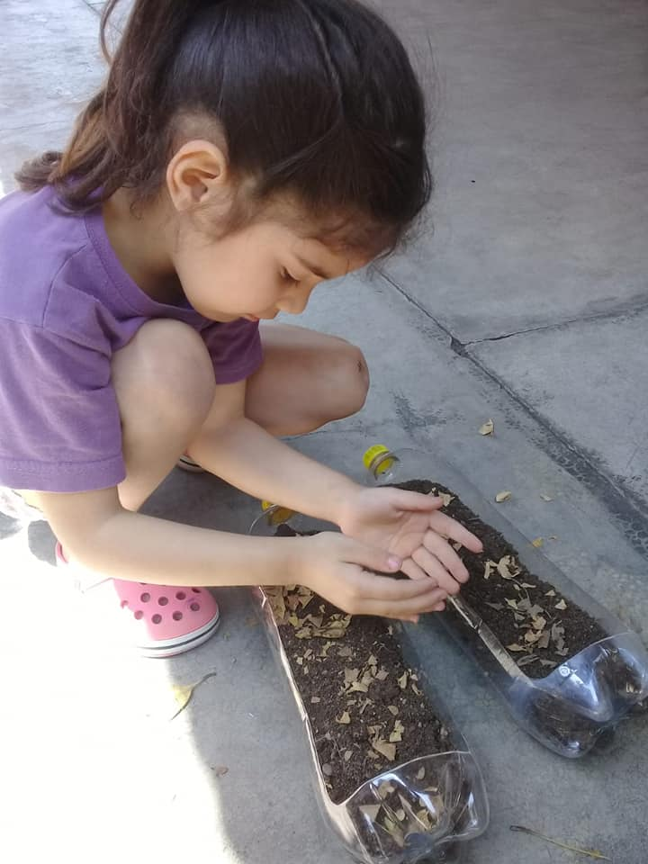

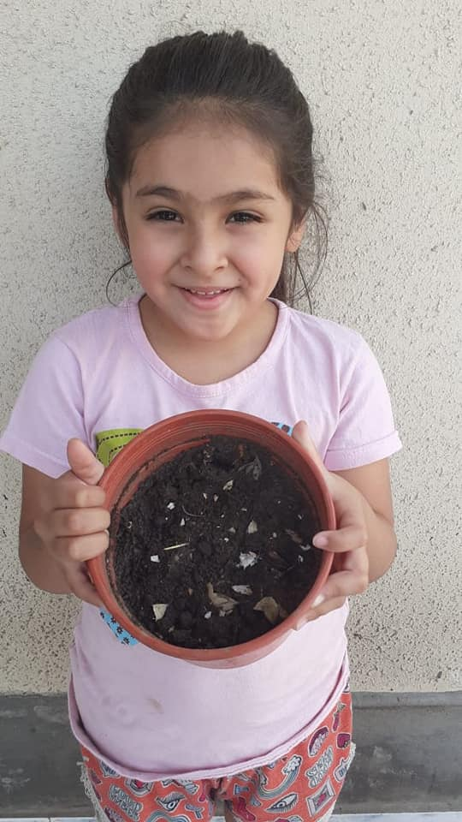

Plant sedes of different fruits and vegetables

