SOS 4Love

Foresting my school and my village to create ecological conscience (Institutional Project)

Esc. Secundaria Dr. Leandro N. Alem
Tucumán, Argentina
2nd Week Work Report
Greater impact pictures
Our action plan is aimed at reducing the negative consequences of climate change through afforestation and reforestation of the area where the school is located, inducing teachers, students and parents to an education for the care of the environment creating green areas and thus putting a granite sand in the global struggle for the care of our Earth planet.

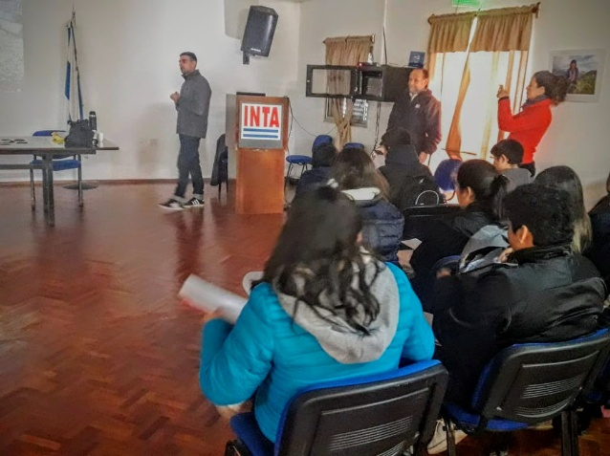
Photos
Students and teachers of our school participating in an informative chat in Instituto Nacional de Tecnología Agropecuaria.

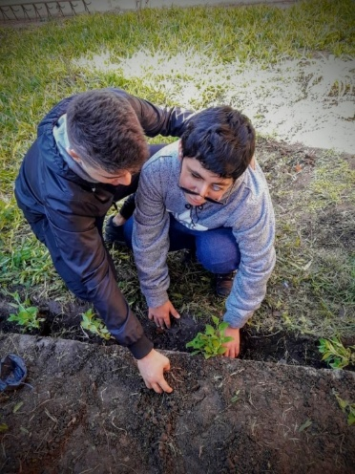
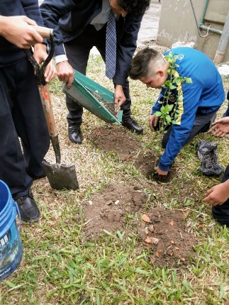
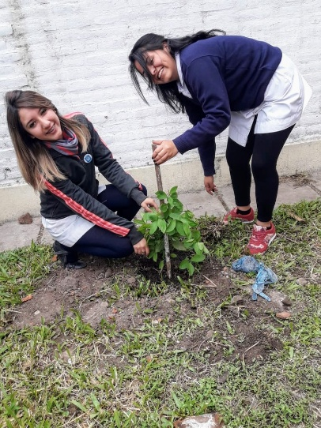
Students with different capacities (blind and deaf students) planting flowers seeds in a small garden built at our school.

Brief information about manager teachers of the project
Delia Isabel Hoilos: (English teacher) She is interested in working with “inclusion” of students with different “capacities” (blind and deaf students)
Julio César López: (History teacher) He is interested and emphasizes at working with his students on natural resources at Esc. Sec. Dr. Leandro N. Alem

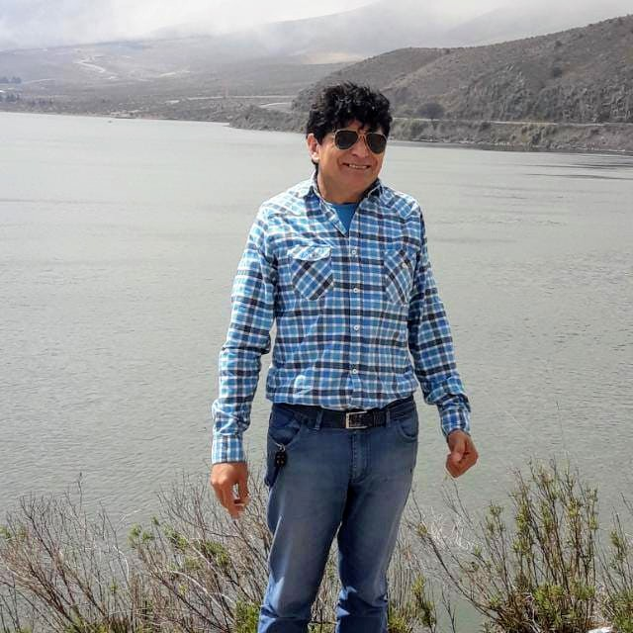
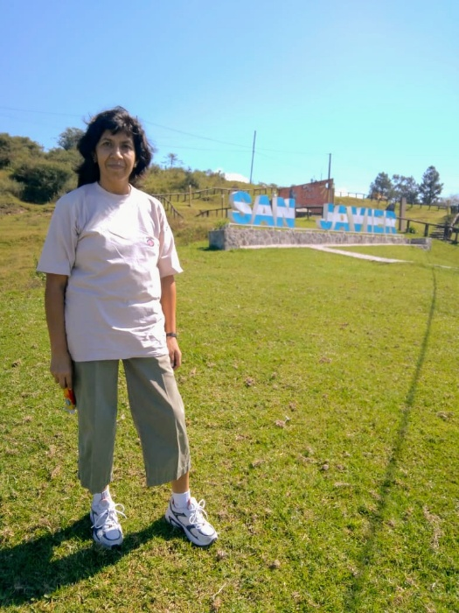

Both teachers decided to work together trying to join their interests in environmental needs and emotional activities connective with their student' realization as real human beings by taking care on our nature because: our future lives depends on it.

