I took a picture of Grade 1 pupils with my mobile while I was telling them about SOS4love project with a cake in the shape of heart
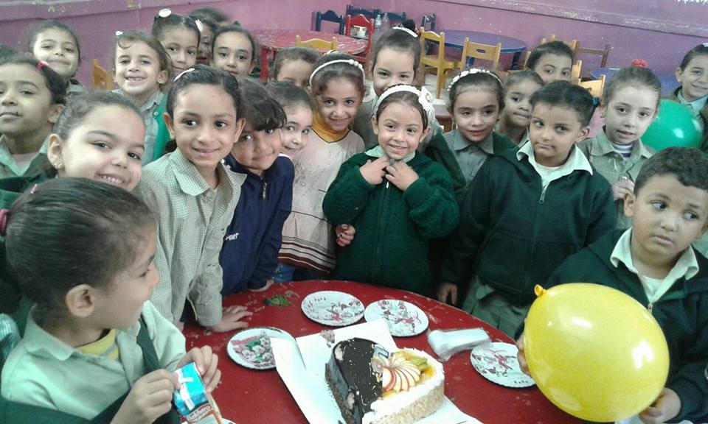

These are my grade 6 pupils calling for peace, non-violence and other ethical values under SOSLoveProject under the umbrella of the united nations

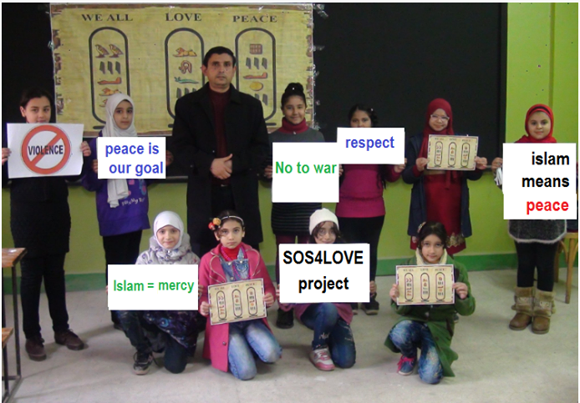

There are many kinds of love such as love of homeland, love of parents, love of peace etc. in this picture, My pupils are chanting about the love of our homeland, Egypt in the school assembly in the morning within the framework of SOS4Love Project. Love is not a word to say but it must be shown in actions because actions speak louder than words. They held hands of each other, they wore the flag of their homeland, they chant together their love
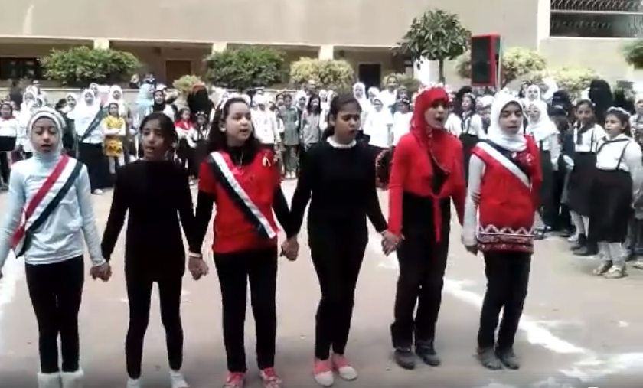

We had the honor to receive the Deputy Minister Mr. Essawi Abdul Ghani in our school (Safwa primary school for girls) His Excellency the Deputy Minister volunteered to give us a speech about the power of love, peace, respect, non-violence and how to stop terrorism
