**SOS4Love Project**

**Final Action Plan Report**

**Please complete & email to** [**info@sos4loveproject.com**](mailto:info@sos4loveproject.com)

**during the 4th Week Report, 5th to 11th of February**

**School/Country:………GREECE……- Glossomatheia………………………………………………………………………………………………………………………………………………………………………………………………………………………………………………………………………………………………**

**Teacher/Facilitator: Name & Last Name-Subject taught in class:…………Maria Davou…………………………………………………………………………………………………………………………………………………………………………………………………….**

1. **Please provide answers to the following questions**:

In Athens, students talk about inequality at schools all the time. Students report that their school teachers behave badly, humiliate students, do not care about students’ problems, give too much homework, deliver boring lessons and offer irrelevant information. Students feel that they are not inspired, included or even interested in what happens at school. Some examples of teachers’ unacceptable behavior are:

- Primary school teachers who shout at students, using degrading language (“you are stupid”, “you are imbecile”, “you are useless” etc.)

- Primary and secondary school teachers just reading out the book when teaching, instead of explaining it.

- Primary and secondary school teachers labelling students, assigning to them stereotypical characteristics and putting them on the spot, evaluating them unjustly or discriminating against some while favoring others.

- Primary and secondary school teachers using corporal punishment to deal with discipline issues.

- Primary and secondary school teachers giving too much homework, demanding of young children to stay up late in order to cope with it.

The problems we have spotted relate with both SDG 4 and SDG 10.

Our idea is to make students of our area aware of these problems, inform students, teachers and parents through a campaign and implement change. We believe that education is the first element of equal, happy, just and loving societies.

The initial steps we have decided to take are:

  Step 1. Interview students from our different schools and report their problems. The interviews will be anonymous so that students speak freely and openly about their problems at school

  Step 2. We will collect students answers and identify 5 main areas of problems that are common to most students and that are serious enough.

  Step 3. We will create a campaign through posters, brochures, emails and facebook posts to inform other students, parents and parents unions as well as teachers and teachers union.

   Step 4. We will create a contract of good and equal conduct and we will send it to all school principals in our area, asking them to have it signed by teachers so as they feel bound to respect students and promote quality education.

    Step 5. We will announce the names of the schools that signed our contract.

DIFFICULTIES:

1. Students might not be willing to open up and share their problems with us.
2. Schools might not want to sign our contract.
3. Teachers might not be willing to accept criticism or admit that they’ve been doing things the wrong way.

_________________________________________________________________________________________________________________________________________________________________________________________________________________________________________________________________________________________________________________________________________________________________________________________________________

1. Which steps will you follow/have you followed to make it happen?

_____________________________________________________________________________________________________________________________________________________________________________________________________________________________________________________________________________________________________________________________________________________________________________________________________________________

**2) Share the results of your SOS4Love project**. ______We interviewed lots of students , identified problems and wrote a contract in English and Greek that was sent to all schools in our area. We are now waiting to see which schools are going to sign it. Here is the document we sent:

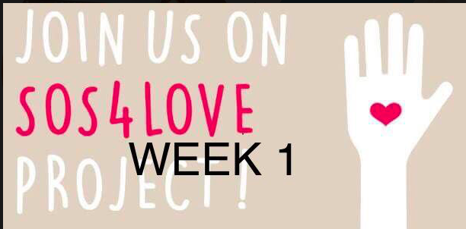

Dear School Principal,

We are students of primary and secondary schools in Kantza and Glyka Nera and we take part in the global project SOS4Love, which is about bringing some kind of change in the world. The topic we chose is Equality in Education. We are sending you this contract that we designed and we hope you and the teachers at your school would like to sign it.

We believe that schools should get better because we spend a great deal of our life in them and they are somehow our second home. We want to learn new things in a happy environment with people who care about us.

If you agree that schools should change for the better, please sign this contract and post it on one of your school walls or bulletin boards.

Let’s change the world! Let’s spread love! Let’s spread the word!

Your students,

Katerina Delimpasi

Nikolas Balkonis

Spyros Sokialis

Philip

Panogiotis

Antony Douros

Kostas Lyropoulos

Sotiris Bletsas

Billy Syrianos

Melitini Vlassa

Mary Dimara

Melina Soulai

Irene Kouki

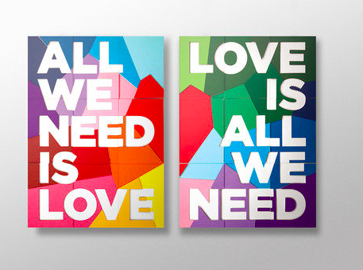

**Contract**

1. We teachers of this school will be nice to all students.
2. We will be fair and promote justice in and outside of the classroom.
3. We will never humiliate the students.
4. We will never make our students feel sad, bad or lonely.
5. We will try to make our lessons as interesting as possible.
6. We will protect the weaker students.
7. We will offer love and support to all the children in our school.
8. We will help our students feel valued and respected.
9. We will understand that students are children and they need time to play and rest.
10. We will protect our students from any kind of abuse or disrespect.

Teachers’ Signatures

**3) Share your feelings and reflections on your experience throughout the SOS4Love project**.

We tried to make a difference about something that is important to us and all children. We want to learn in safe places, in equal terms and in fairness and justice. We believe that most teachers will sign the contract we created and this will make them better teachers.

Thank you for Acting 4Love World-Changers! Looking forward to seeing you next school year in the SOS4Love Project again, to Keep Changing the World Together with #Pedagogy4Love!