Topic: Production methods based on Circular Economy

Delimitation of the problem:
The theme to be addressed as a problem appeared in articulation with various main subjects of the institution. These subjects, which have interdisciplinary content, made us rethink the strategies of production of goods, in other words, the reuse of existing natural resources in the area, in terms of their best use.
In the town of Burruyacú and surrounding communities, where we came from, we observe that these natural resources, specifically land in small plots, are devalued.
Why do we say this? Because the majority of the available manpower has the aim of looking for work in the farms of the area; when it is possible to produce on a small scale and its subsequent consumption and commercialization.
Problem identification: devaluation of small-scale natural resources in the field of the Circular Economy.
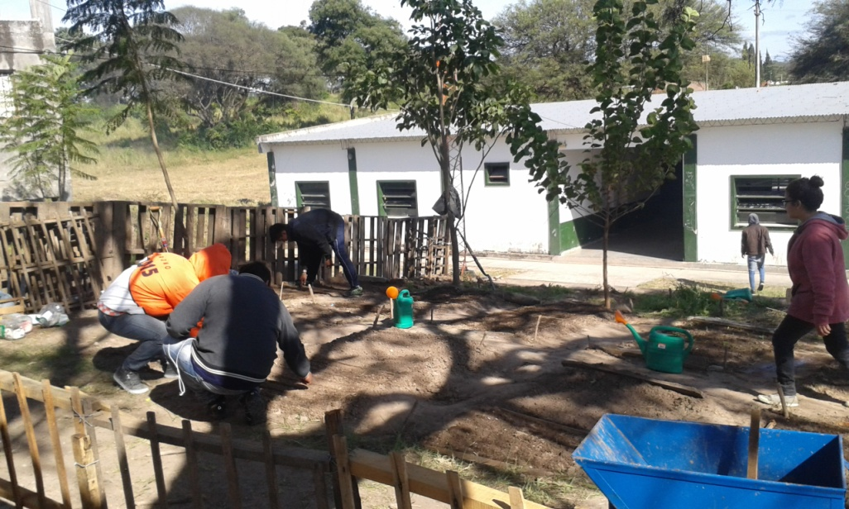

Goals
The recycling of existing natural resources in the area, in terms of its best use, would bring the following benefits:
- The production of vegetables, organic type, promoting their consumption for the benefit of human health, through canning and reuse of waste as fertilizer for the land.
- The possibility of promoting local development, through an economic activity that drives a local economy and improves the living conditions of the community.
- Generation of networks of small producers as work alternatives, constituting economic development with social impact.
This tertiary institution trains the students for the labor market, either as entrepreneurs or as part of a larger organization. Therefore, the technological project can be the starting point of a small business.
- The project that will solve the problem is the following:
Project: preparation of canned products
The focus of this project is the following: in Burruyacú, most families have small plots of land that can be used in the production of vegetables and other products. All agricultural production is seasonal, it is produced at a time of the year, for example, in an orchard we need small land, when the time of its production arrives, the vegetables ripen at the same time, it is not possible consume all the vegetable production many times . The consumption of vegetables is inelastic, they are perishable products, that is to say if they are not consume in a certain time they will be put in poor condition. This situation leads us to seek strategies for their conservation. Therefore, we propose the alternative of conservation of vegetable products.
- Steps to be taken for the preparation of canned vegetable products
Ingredients: carrots, red, green and yellow bell peppers, chives, broccoli, chili peppers, 4% alcohol vinegar, salt and glass jars.
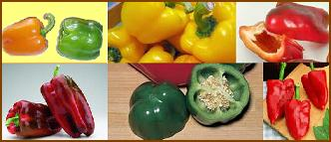
Process:
- Sterilization of the glass jars => “at a temperature of 100 ° C the pathogenic microorganisms are eliminated, the bottles and lids are immersed in boiling water for 2 minutes. For a total sterilization, the water is removed from the bottles and they are placed in a baking tin, face down; then the baking tin is taken in the oven for 2 or 3 minutes. After this procedure, it is immediately packed with the vegetable product.
- Wash all the vegetables.
- Peel the chives
- Peel the carrots and cut into sticks.
- Separate flowers from broccoli.
- Cut the bell peppers in the middle, remove the white part and the seeds and cut into sticks.
- In a pot with boiling water, put the carrots in a colander and introduce the cut carrots for about 2 minutes. This procedure is carried out to scald this vegetable, this means that it highlights its pigment, and also to give it more meatiness. Highlights its qualities, color and flavor.
- In a clean jar put all vegetables and cover liquid, 4% vinegar.
- In a pot, place water and bring to a boil for 3 or 4 minutes, the boats already packed. Cover the bottle with the hot liquid and close tightly.
- In about 2 weeks the canned vegetable products will be ready. The bottles weigh 480 gr. of which, 60% corresponds to plant products and 40% is cover liquid.
- Cómo se pronuncia
Weaknesses
- Lack of physical space for canning.
- Lack of mobility for product distribution.
Threat
- Weather conditions.
- Emergence of pests and diseases.
- Possible incorporation of new canning producers.

Modality of implementation:
- Use of social networks and school radio for the dissemination of the project.
- Conduct of interdisciplinary-tutorial training for students in 1st, 2nd and 3rd of the current Technicature.
- Talks in the institution with organizations such as I.N.T.A. and specialized professionals, for the educational communities and the community in general.
The mentioned talks will consist of:
• Talks referring to the theme involved in the project: Circular Economy, Local Development, Plant Production, Sustainability of natural resources, among others.
• Workshop on techniques and methods for preparing canned and vegetable derivatives.
• Training for edition of brochures and labels with Publisher program.

FEASIBILITY OF THE PROJECT AND EXPECTED RESULTS
Before making the decision on the feasibility of developing this project, different proposed alternatives were analyzed, which were rejected because they did not meet some of the expectations within the logic of the circular economy and local development, such as pollution of effluents, environmental impact, etc. In addition, it is not characterized as a project that require high investment, complex infrastructure, specific equipment, dependence on inputs, which in turn are expensive and difficult to appropriate.
Likewise, the possibility of carrying out the development of the project becomes as a viable alternative within the possibilities of the students of the institution which can be supported by other local actors such as the local government of Burruyacú, the parents of the students who are part of the community, by the educational institution, since the students and I have the collaboration and advice of teachers who have solid knowledge for their professional experiences, also with the collaboration of important organizations such as INTA (Instituto Nacional de Tecnología Agropecuaria), I.D.E.P. (Instituto de Desarrollo de la provincia de Tucumán)
Among the characteristics of this small-scale plant production you can visualize the way forward to achieve the proposed objectives, since:
- Low surface area is required for plant production
- Its production is not polluting, that is to say organic vegetables for the benefit of human health, encouraging consumption by means of canning and other derivatives; and the subsequent use of waste as compost.
- A minimum initial investment is required according to the possibilities of the inhabitants of the area; promoting local development, through a genuine economic activity that drives the local economy and improves the living conditions of the community.

