STUDENT GROUP OF THE APOSTOLOU PAVLOU GIMNASIUM
ELENI DIOGENOUS
ALEXANDRA PANAYIOTOU
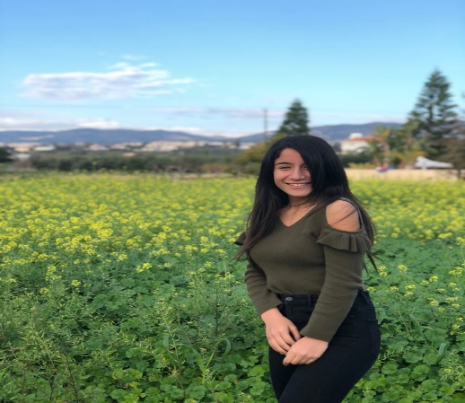
ANDREANA GIOUKKA

