SOS 4Love
Foresting my school and my village to create ecological conscience
(Institutional Project)
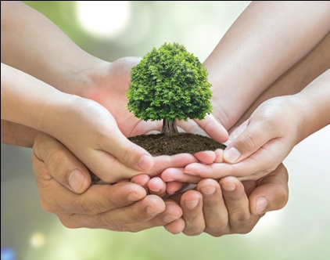
Esc. Secundaria Dr. Leandro N. Alem
Tucumán, Argentina
Last report
We decided to work in this interesting experience because we belong to small public school in the North of Argentina in a province called Tucumán, we want an wish teacher and students from all over the world now that we are carrying out a task which is very committed to the environment, we try to raise a awareness in all members of the educational community and in our society (our neighborhood has outdoor spaces: new squares) to take care of and to maintain interest in nature.
We emphasize that our educational institution is called “inclusive”; because there are blind and “hearing impaired” students accompanied by the support teachers while attending classes.
All the reports were made by students by using dictionaries and internet as technical support.
We wish trough task could be so significant.
Students learned the most important thing, which is “working as a real team” and especially because they used the foreng language to communicate their experience to the world.
Trying to join aulic knowledge (pedagogical aspects) with different ways of acting in society (values) for which we carry out activities in those they could share experiences: with parents, students, teachers, community in general.
“A grain of sand on the beach, drop of water in the ocean”
All our effort adds up when it comes to taking care of “nature” to avoid greater damages on it the future.
By planting trees and plants we are preventing floods. Because of this beautiful birds on the trees show as in there magnificent flight that we also make their lives free.
“If we can and believe in nature we can protect it”
Finally, we want to thank to Javier Granero (student) who always helped to write about our institutional project.
