“ALL WE NEED IS LOVE”
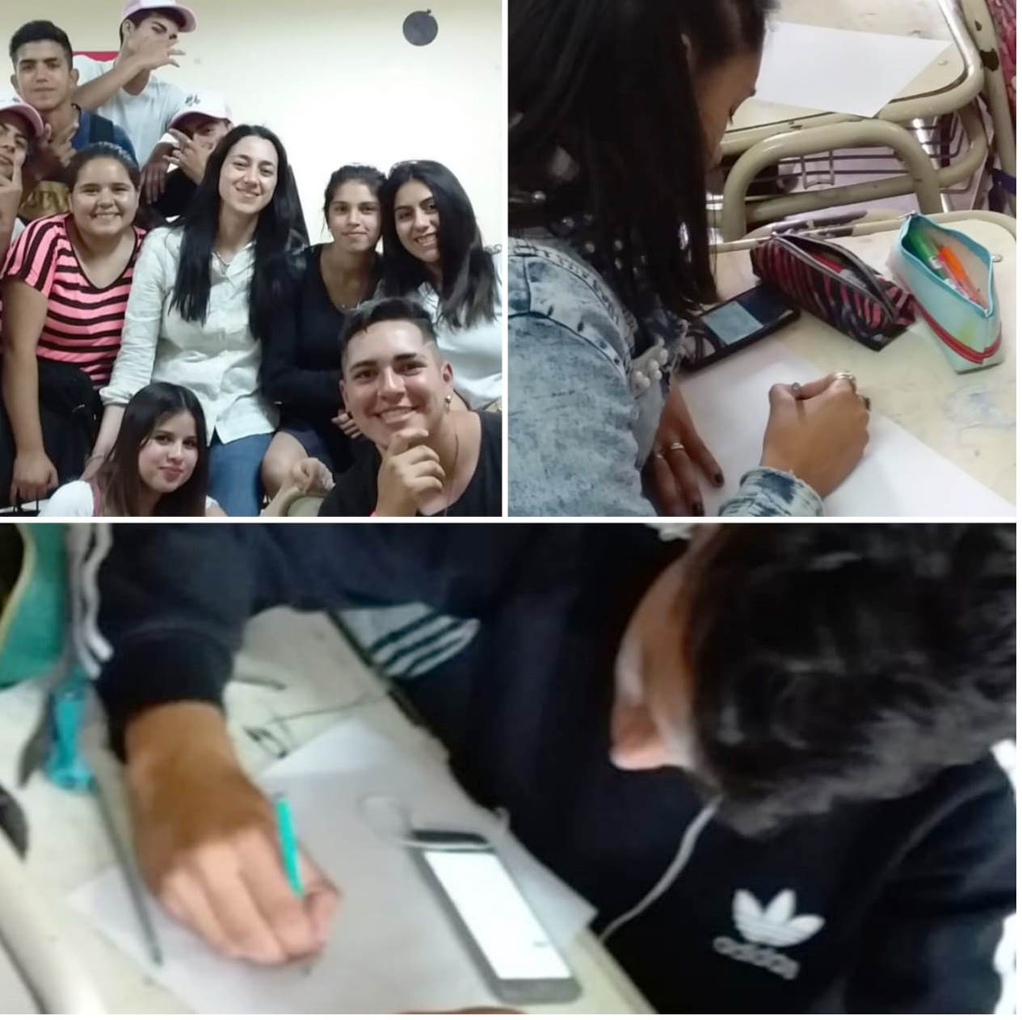
Here we are. My students and me. In these pictures we are working for PEACE and LOVE.

