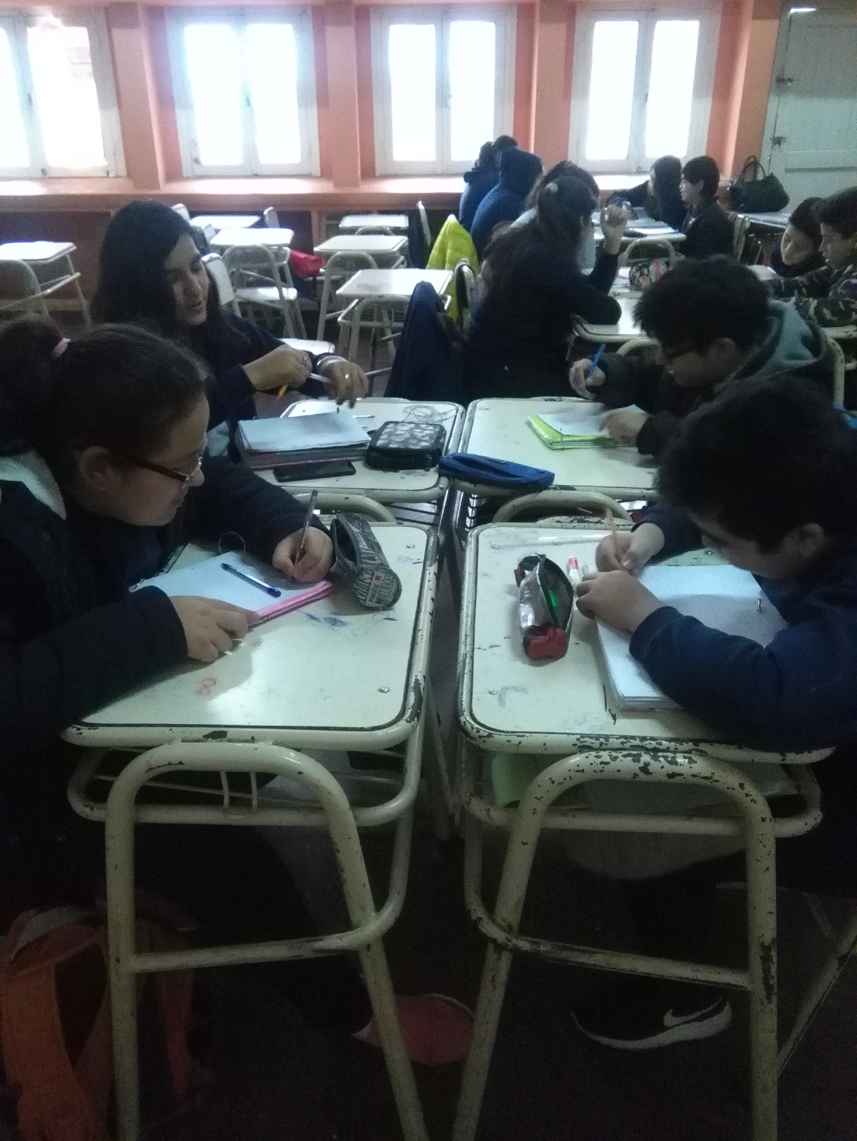
After presenting the project, students got enthusiastic about the idea of knowing how to take care of water. Last week, we looked information about how people from our country waste water, and how they can avoid doing that.

