"FRAY CAYETANO RODRIGUEZ" PRIMARY SCHOOL, City: TAFI VIEJO, Province: TUCUMAN, Country: ARGENTINA
Number of students: 30 course: 6 A

STUDENTS WATCHING THE WEBPAGE OF SOS4 LOVE PROJECT AND THE VIDEOS
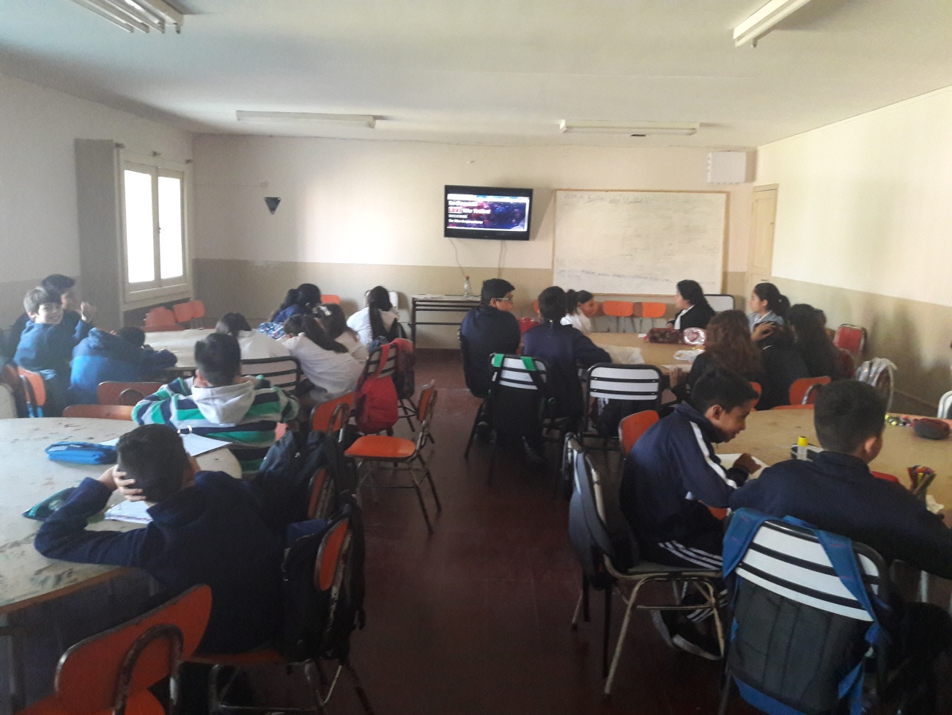
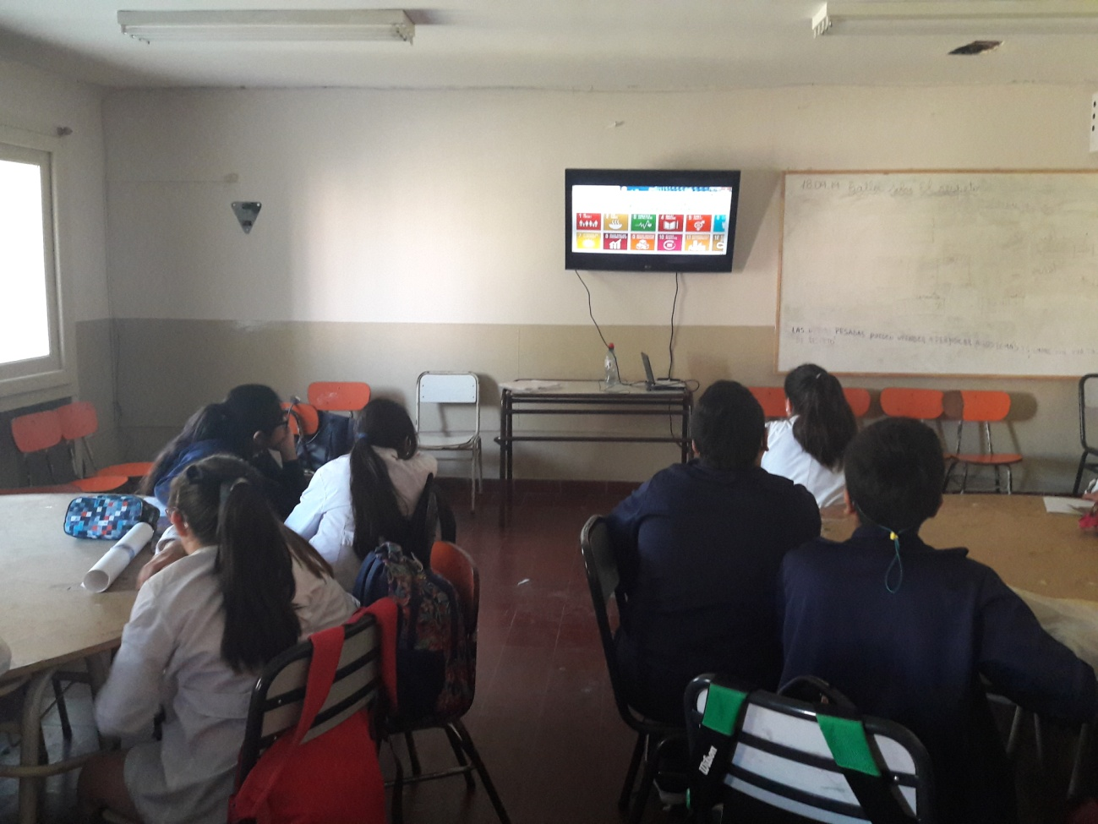

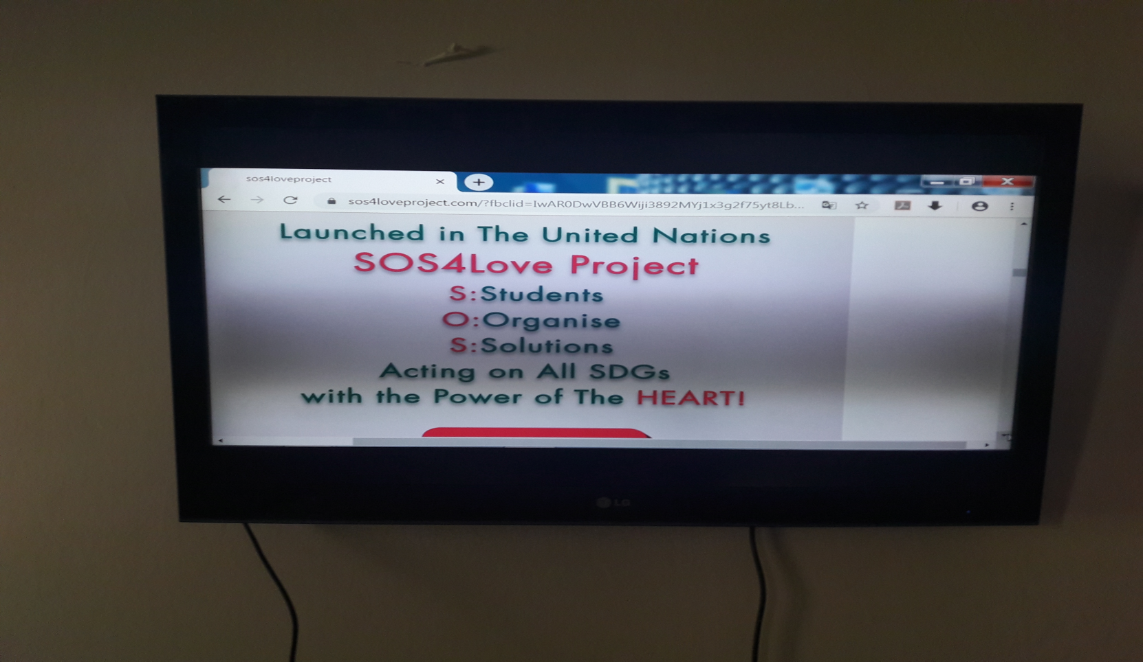
This is one of the videos that students have seen in a science project they made at the beginning of the year about “TAPIR” one of the endangered species in, our province, Tucumán. The name of this project was “TAPIR PROJECT”
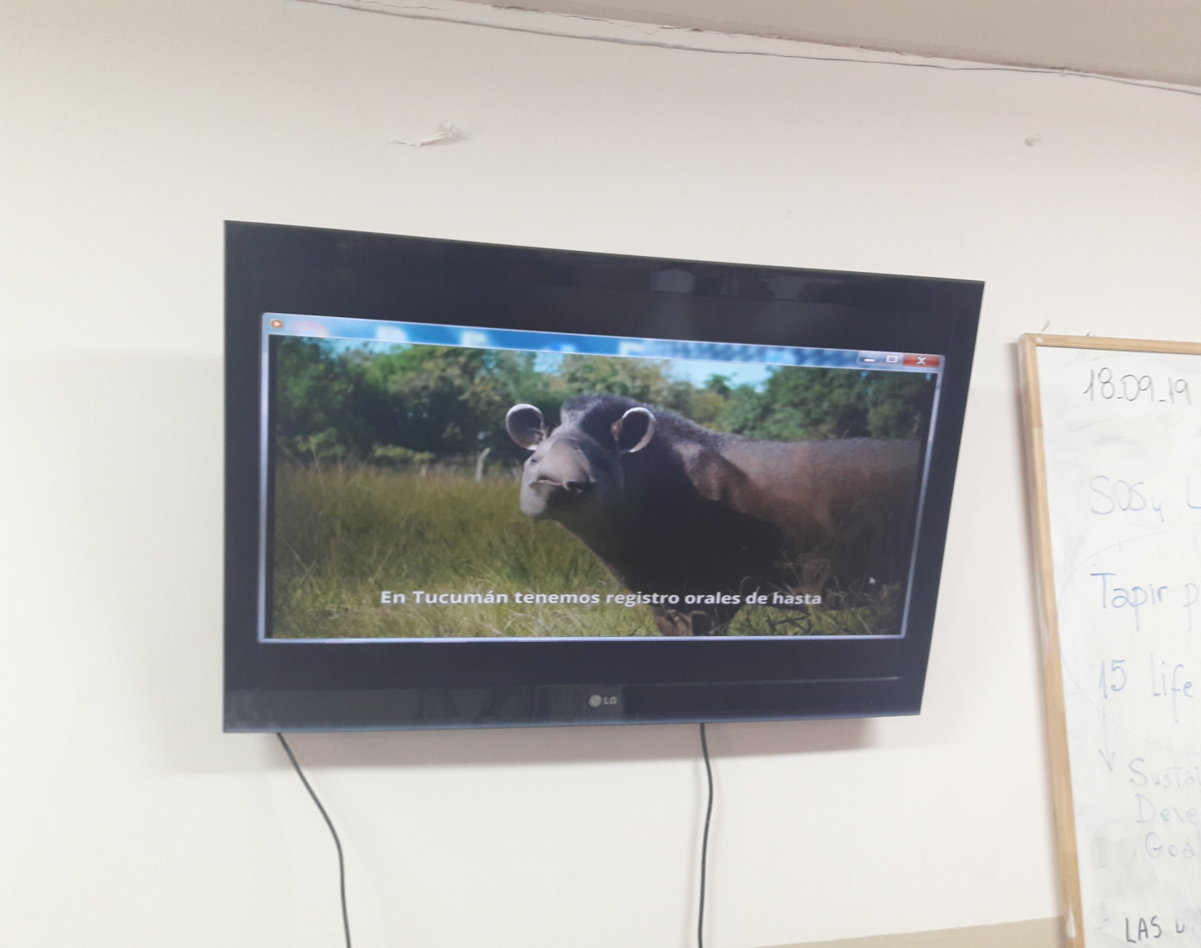

Students working to connect SOS4 LOVE Project, SDG Nº15 of the UN and their science Project “ Tapir Project”

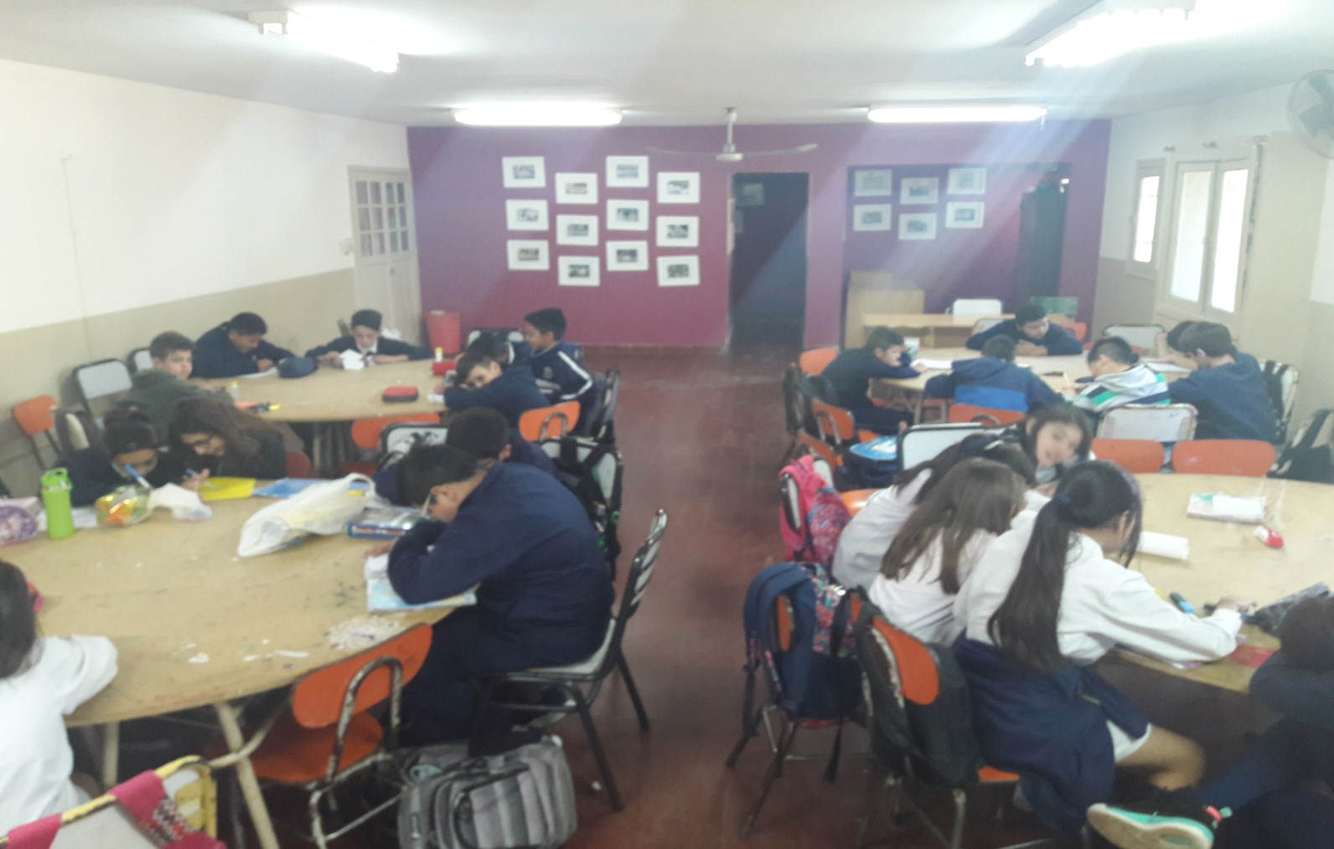
Teacher – facilitator name: SILVIA SALADO. She was born in Tucumán, Argentina (31st May 1968). She is an English teacher for elementary level with 30 years of expirience.

