SOS4Love Project
‘PLASTIC, BIODEGRADABLE, OR FABRIC BAG?
Which one would you choose to carry your groceries?’

Efi Dariou¹, Marianna Ioannou², Stella Timotheou³, Maria Vasiliou⁴

Collaborating schools: 1: Agios Spyridonas Strovolou Primary School, 2: Katharis Primary School – Dimitris Lipertis, 3: B’ Ormideias Primary School, 4: Parekklisias Primary School, Cyprus

Collective citizenship actions: Raising awareness of the wider local population, through informing the school and local community about students’ decisions in relevant with our SOS4Love Project
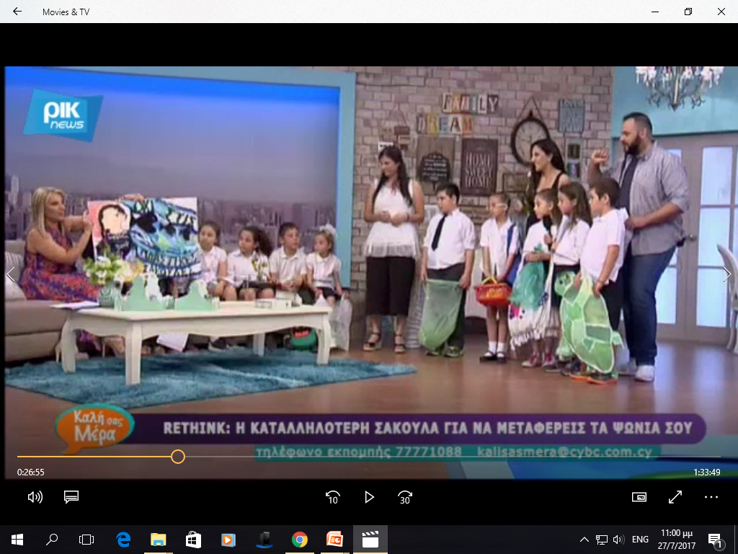
Participate in a TV show
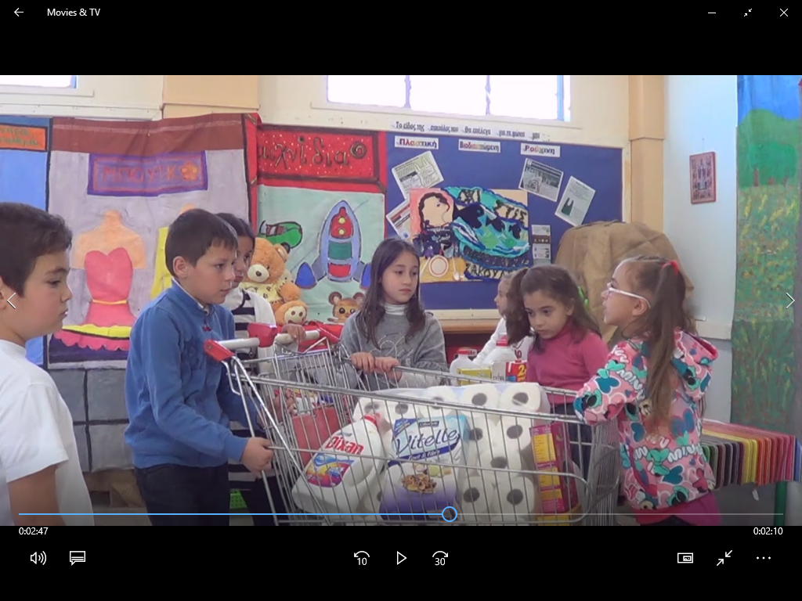
Writing a script and creating a TV spot
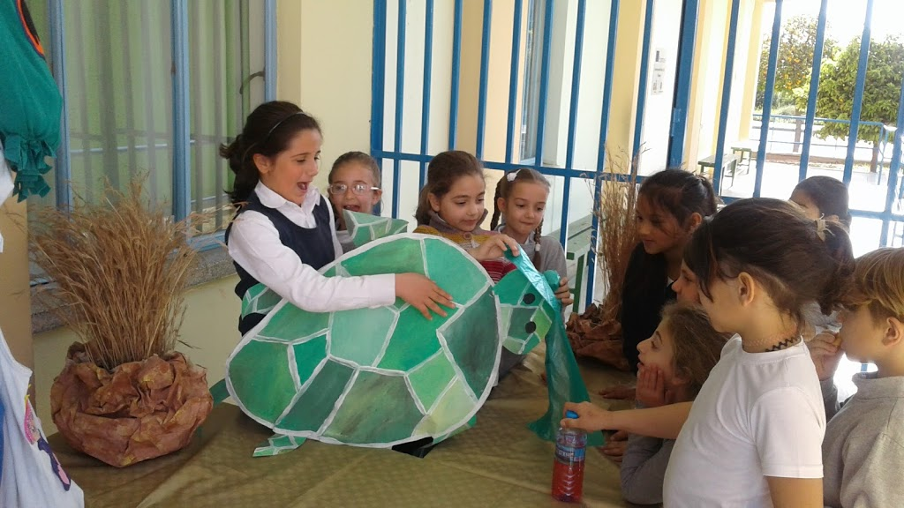
Representation of a turtle choking script
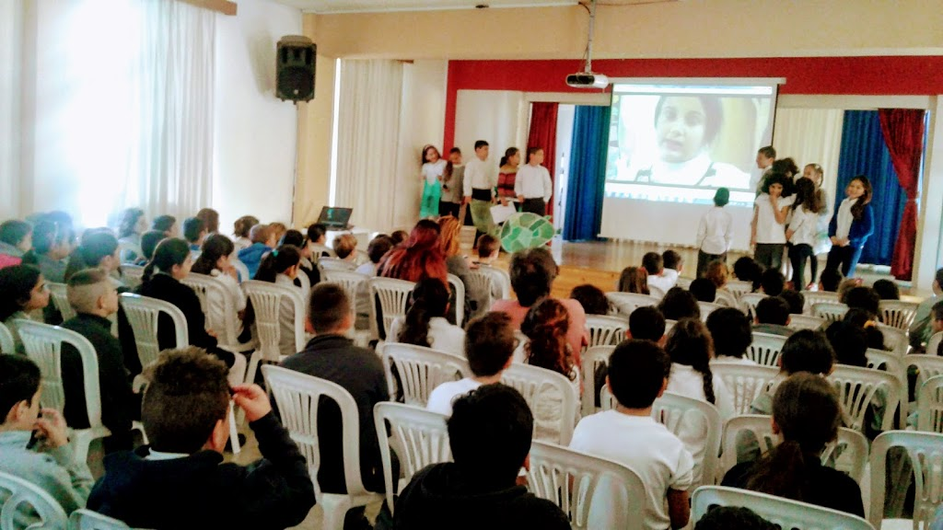
Presenting information to the schoolmates
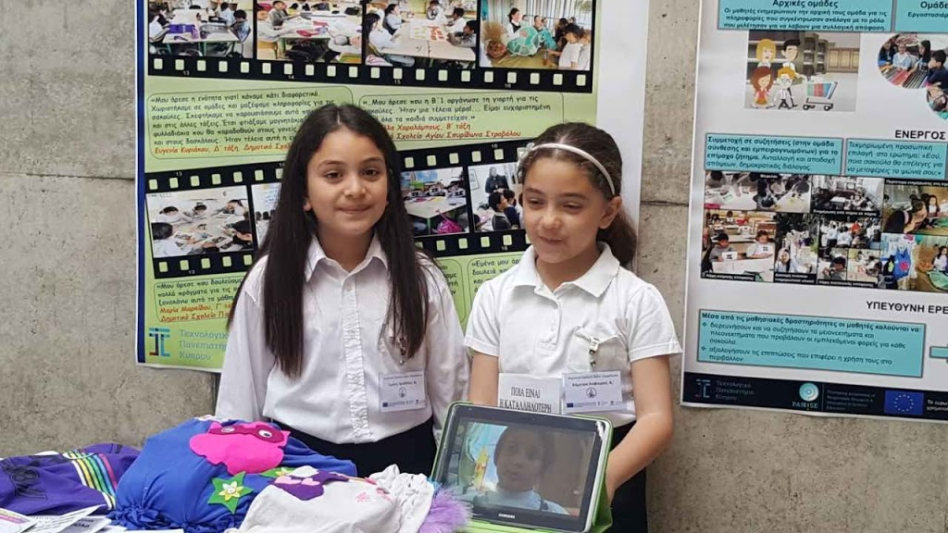
Presentation at local conferences
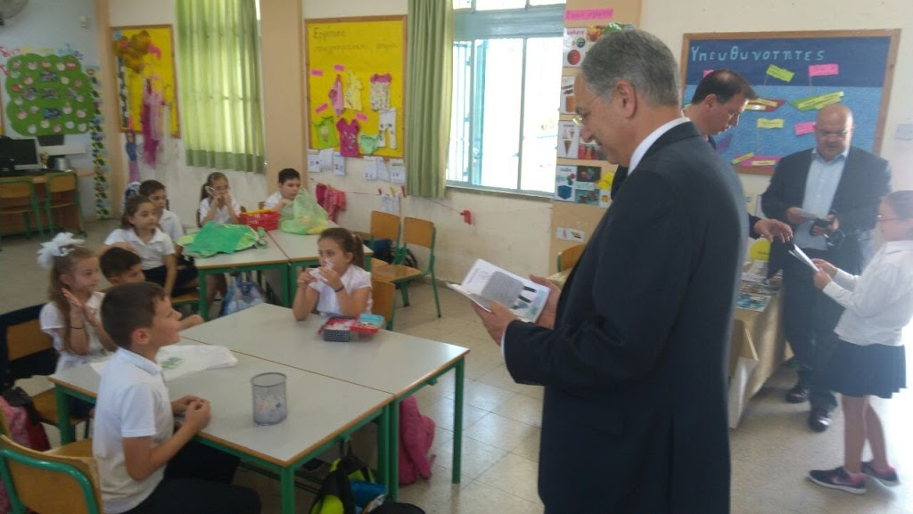
Mitigation measures to the Minister of Education
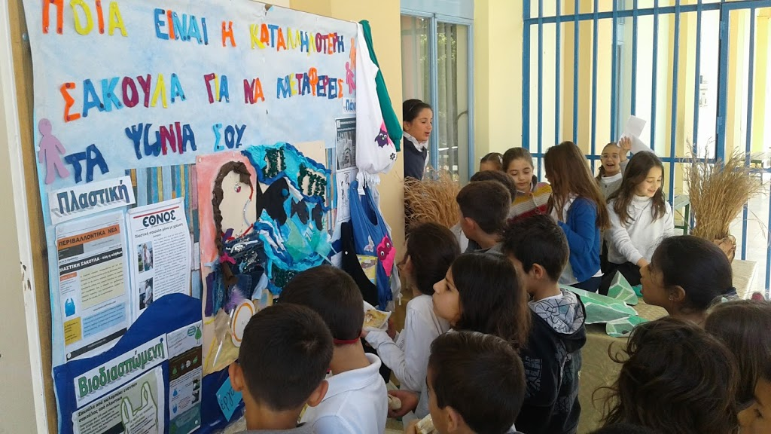
Setting up an information stand in the schoolyard
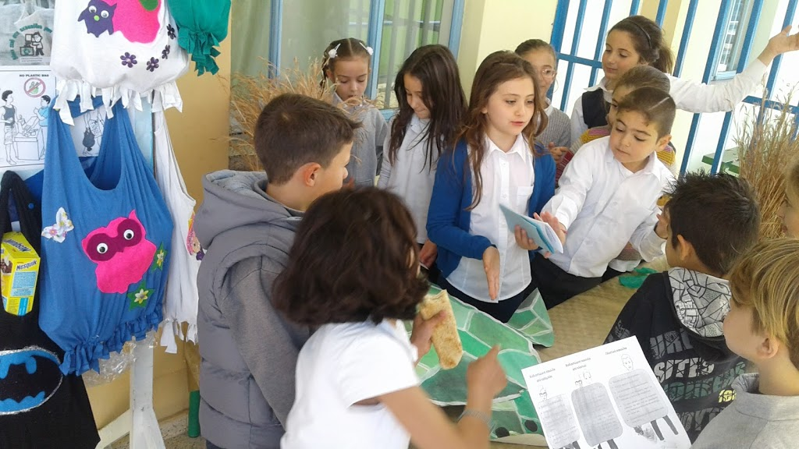
Promoting fabric bags
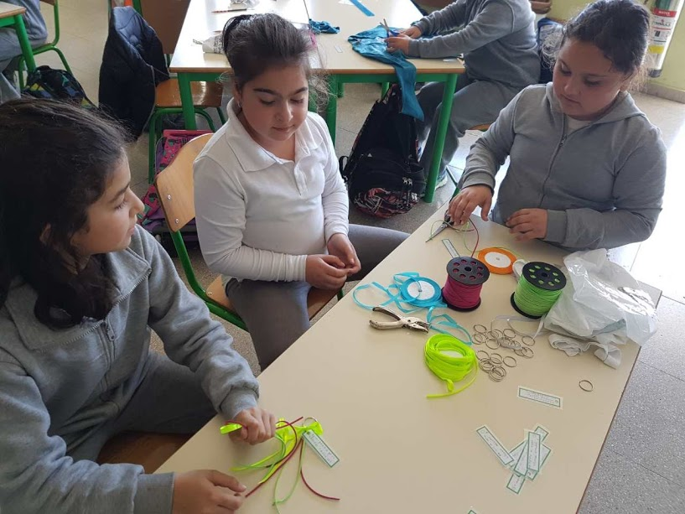
Creating key rings and magnets
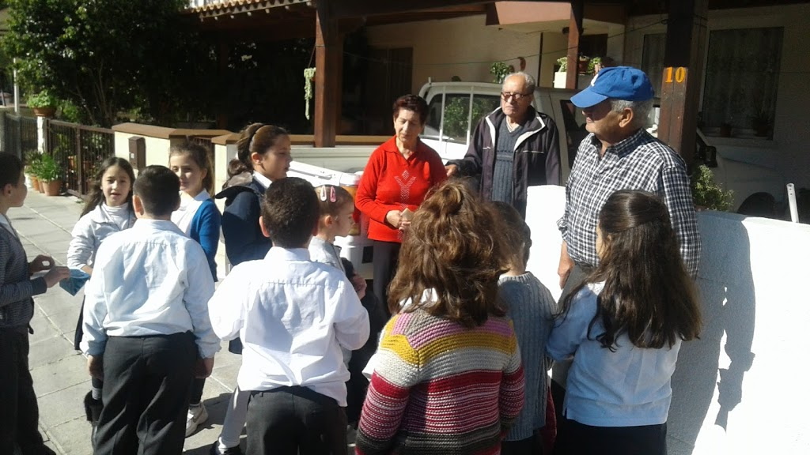
Providing door to door information
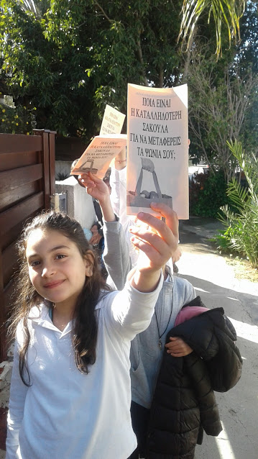
Sharing information brochure

